Automatic Transmission Controller

Introduction:

This project aims to model an automatic transmission controller. It is composed of modules which represent the engine, transmission, and the vehicle, with an additional shift logic block to control the transmission ratio. Stateflow is used for enhancing the Simulink model with its representation of the transmission control logic.

The Block Diagram that is implemented in the project implements the blocks from this figure as modular Simulink subsystem. It shows the power flow in a typical automotive drivetrain. Nonlinear ordinary differential equations model the engine, four-speed automatic transmission, and vehicle. The logic and decisions made in the Transmission Control Unit (TCU) do not lend themselves to well-formulated equations. TCU is better suited for a Stateflow representation. Stateflow monitors the events which correspond to important relationships within the system and takes the appropriate action as they occur.

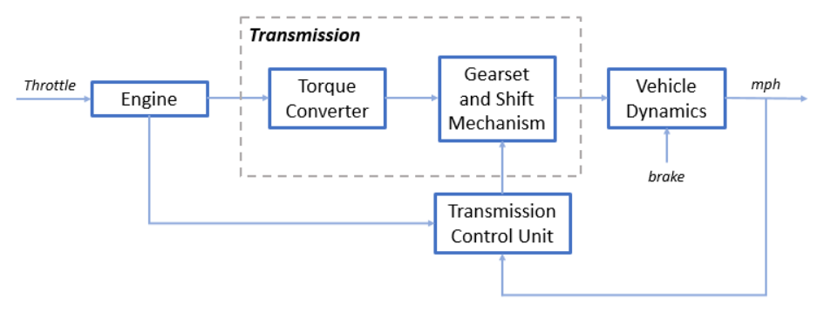

Equations:

There are 5 equations that govern the logic for the model.

The throttle opening is one of the inputs to the engine. The engine is connected to the impeller of the torque converter which couples it to the transmission as in equation 1:

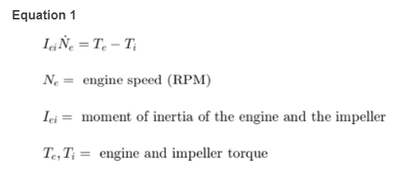

The input-output characteristics of the torque converter can be expressed as functions of the engine speed and the turbine speed as in equation 2:

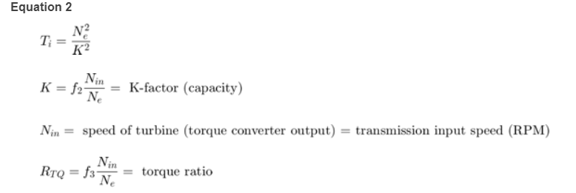

The transmission model is implemented via static gear ratios, assuming small shift times as in Equation 3:

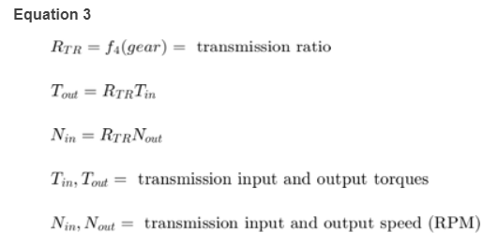

The final drive, inertia, and a dynamically varying load constitute the vehicle dynamics as in Equation 4:

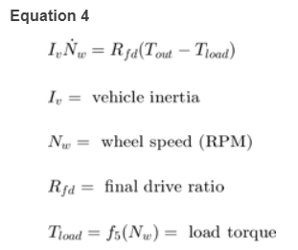

The load torque includes both the road load and brake torque. The road load is the sum of frictional and aerodynamic losses, as in Equation 5:

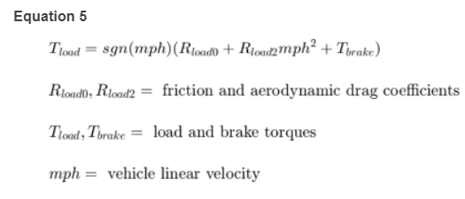

The Simulink Model of the Automatic transmission controller consists of the following blocks:

Engine Block:

The Engine subsystem consists of a two-dimensional table that interpolates engine torque versus throttle and engine speed.

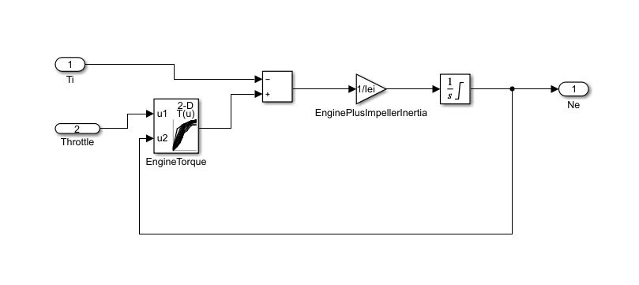

The Torque Converter and the Transmission Ratio:

These blocks make up the Transmission subsystem.

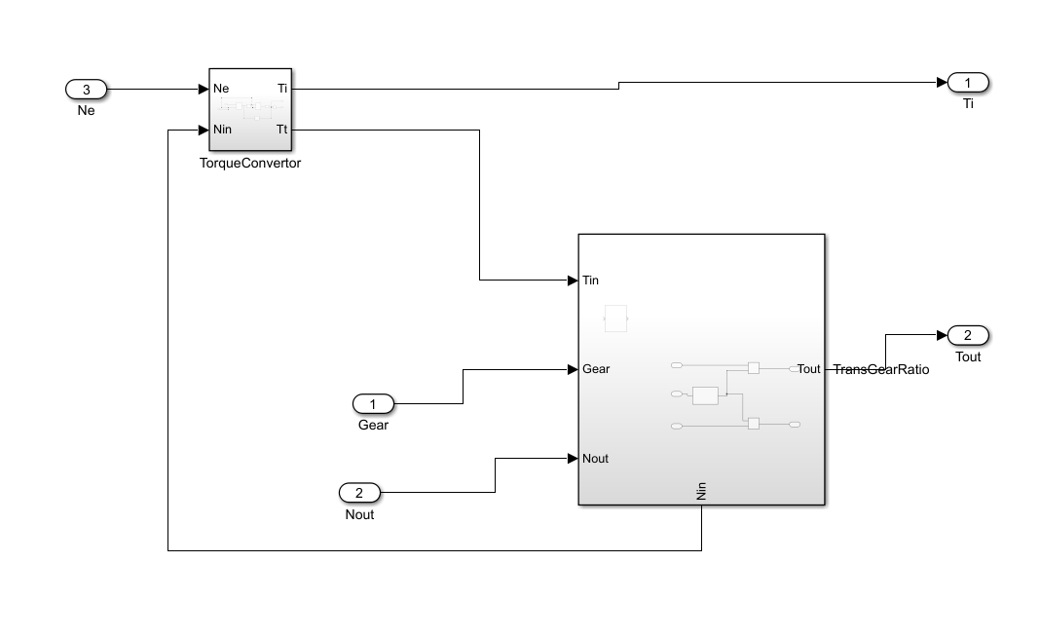

The Torque Converter is implemented in Equation 2.

The transmission ratio block computes the transmission output torque and input speed, as indicated in Equation 3.

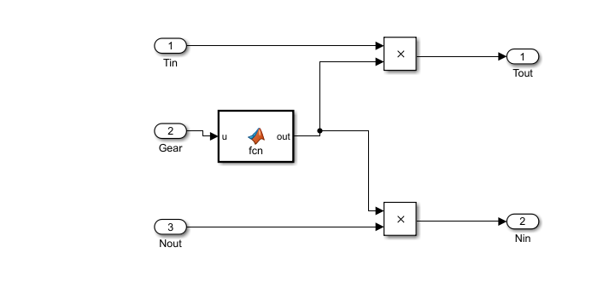

It uses MATLAB Function to choose the Transmission Gear Ratio.

Shifting Logic:

Shifting Logic implements gear selection for the transmission. Two dashed AND states keep track of the gear state and the state of the gear selection process. The overall chart is executed as a discrete-time system.

The shifting logic chart contains 2 parallel blocks.

If the vehicle speed does not satisfy the shift condition, while in the confirm state, the model ignores the shift and it transitions back to steady state. This prevents extra shifts due to noise conditions. If the shift condition remains valid for a duration of TWAIT ticks, the model transitions through the lower junction and, depending on the current gear, it broadcasts one of the shift events. Subsequently, the model again activates steady state after a transition through one of the central junctions. The shift event, which is broadcast to the gear selection state, activates a transition to the appropriate new gear.

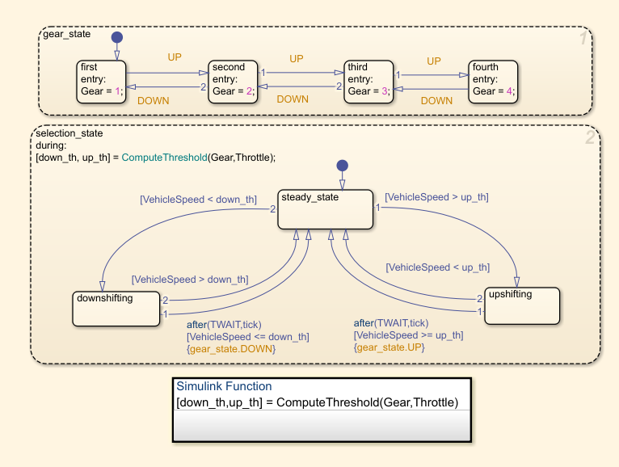

Vehicle Block:

The Vehicle subsystem uses the net torque to compute the acceleration and integrate it to compute the vehicle speed, per Equation 4 and Equation 5.

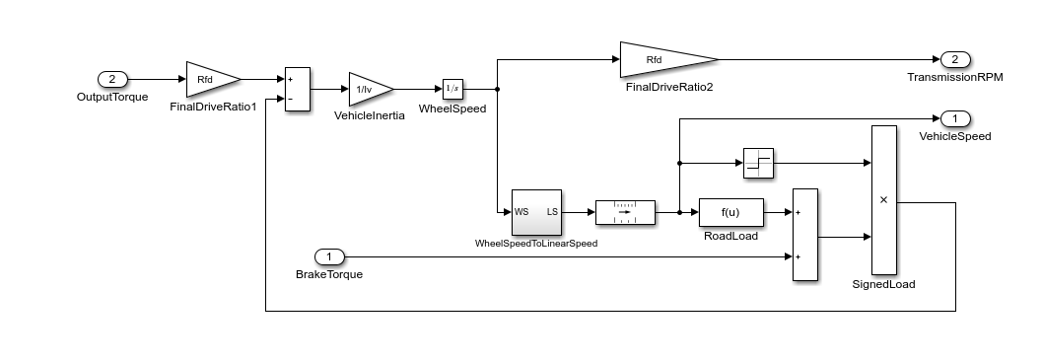

The following skills have been demonstrated in the Automatic Transmission Controller Model:

1. Call-backs

For the implementation of the call-backs, Clearvars function is used at the Closefcn for preventing the variables of the next model that is opened to get assigned to the pervious model that is worked upon.

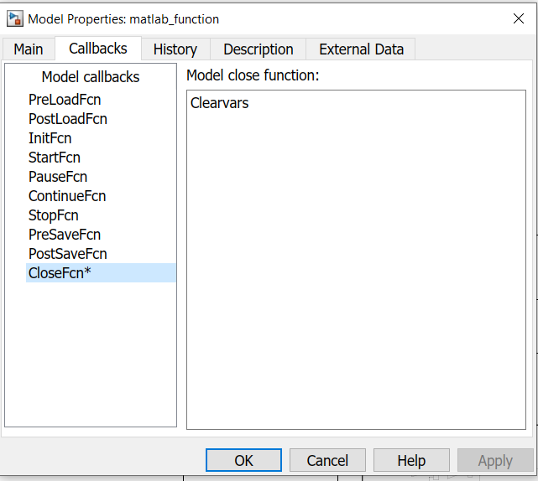

Data Inspector

The required output and input graphs are shown by logging the signals and seen simultaneously.

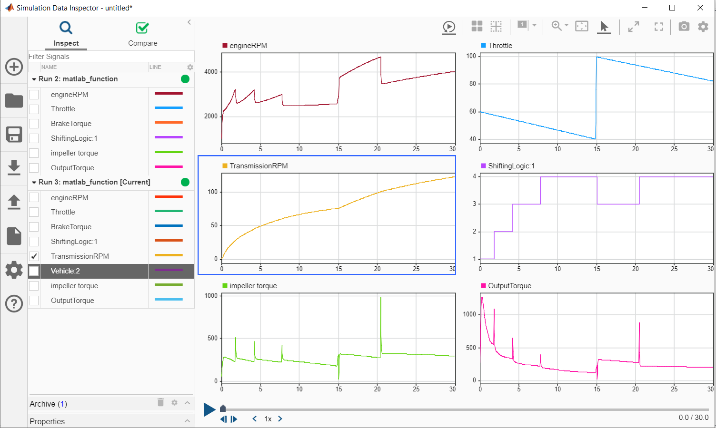

1. Solver selection strategy

The model uses the ode5 Dormand-Prince formula to compute the model state at the next time step as an explicit function of the current value of the state and the state derivatives approximated at intermediate points. It is used for the most accurate output.

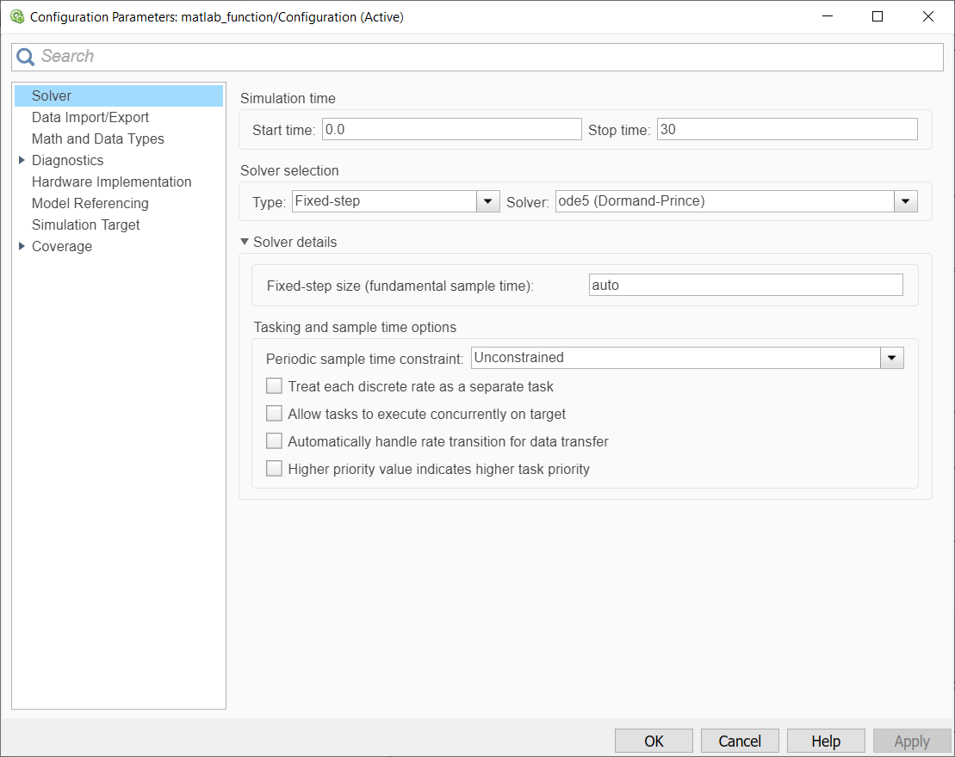

1. MATLAB function block

MATLAB function block is used for changing the transmission gear ratios for 4 different gears.

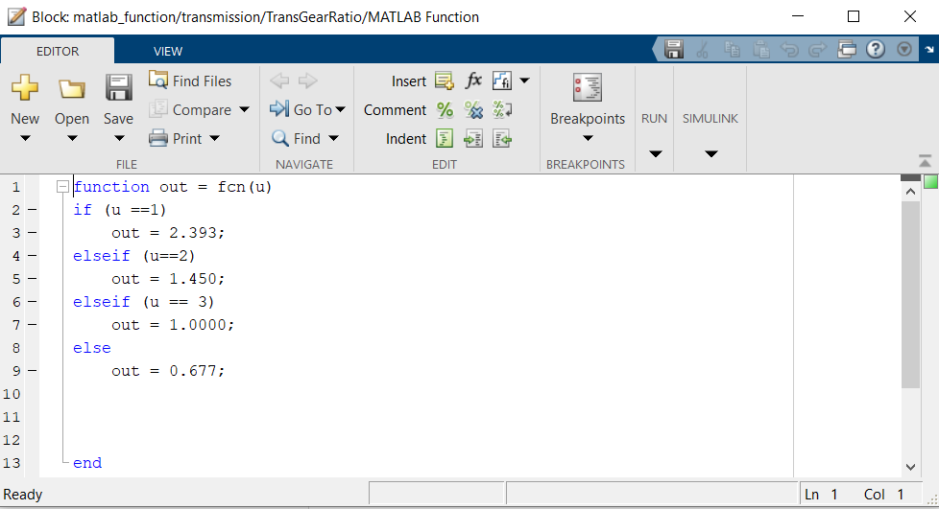

1. Look-up table

The model uses 3 Look-up Tables:

One 2-D lookup table consists of the data for the Engine torque in the engine block.

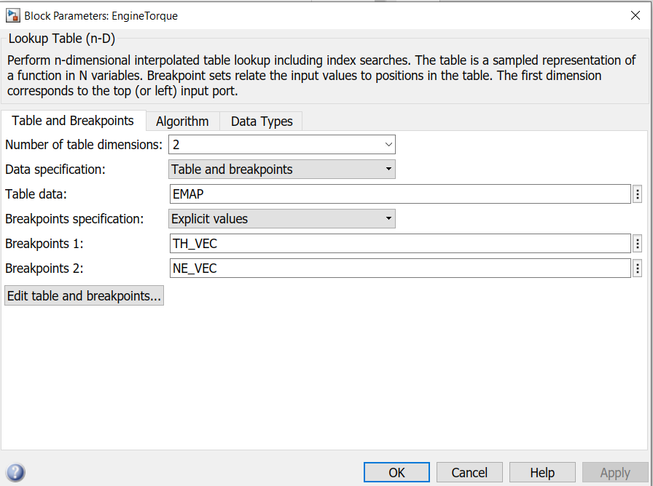

There are two 1-D lookup tables that consists the data for Speed Ratio to Factor K and Speed Ratio to Torque Ratio. These three ratio speeds are present as an array in CONVERTER_DATA variable.

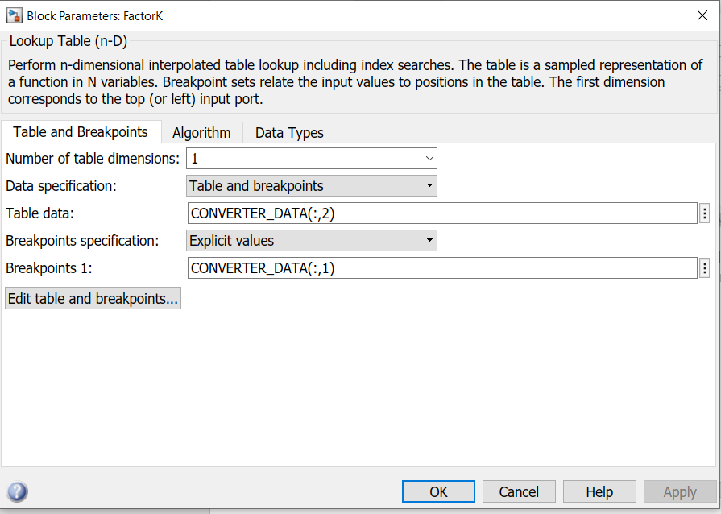

Factor K

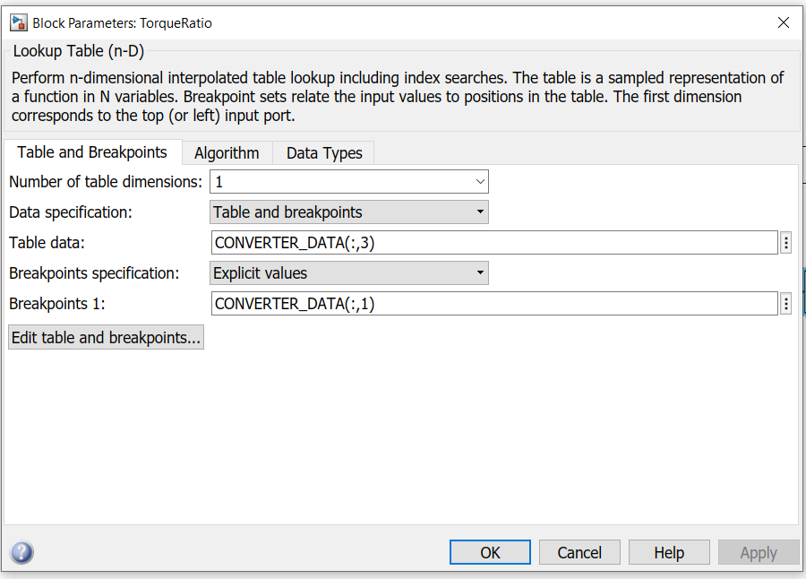

Torque Ratio

1. Signal Builder

The model uses the signal builder to generate signals for throttle and brake inputs in 4 conditions:

* Passing Manoeuvre
* Gradual Acceleration
* Hard Braking
* Coasting

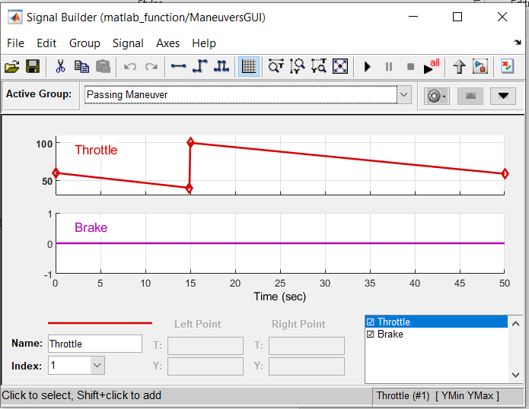 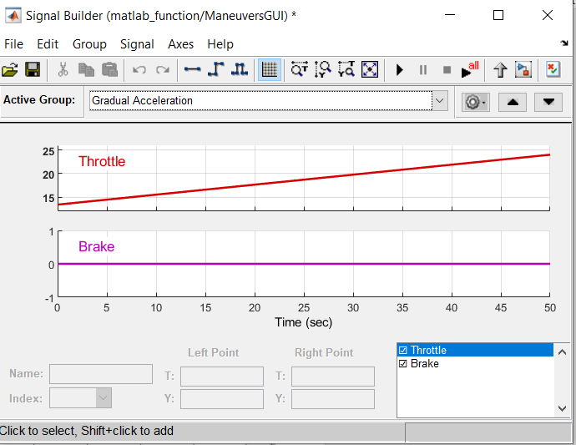

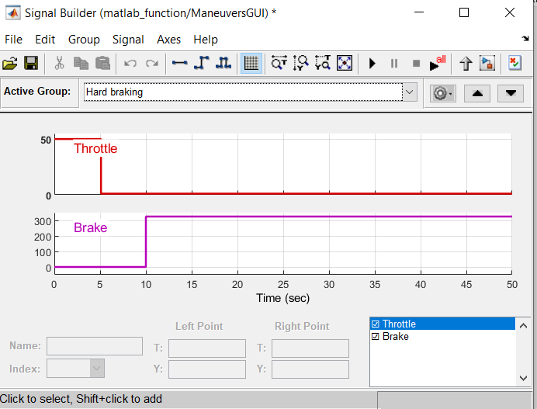 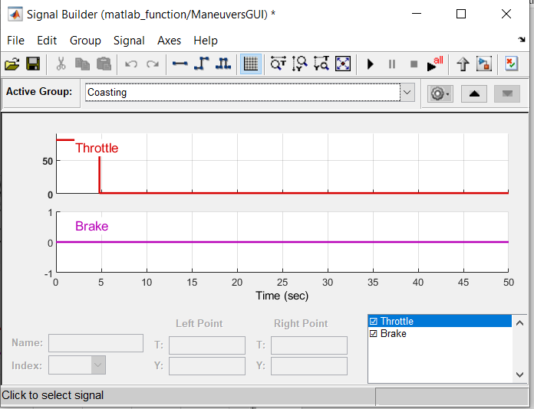

Output on Scope:

There are 4 outputs for different vehicle conditions which depict the behaviour of the Engine RPM and the Transmission RPM for throttle as input.

1. Passing Manoeuvre

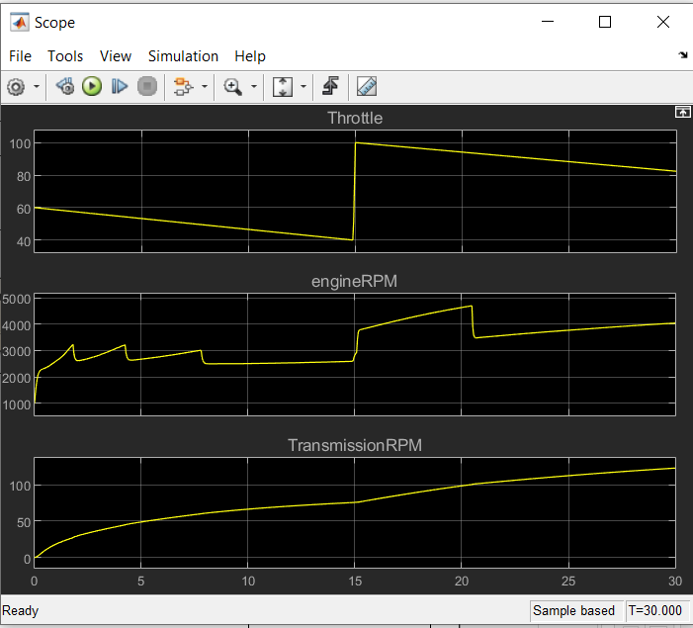

1. Gradual Acceleration

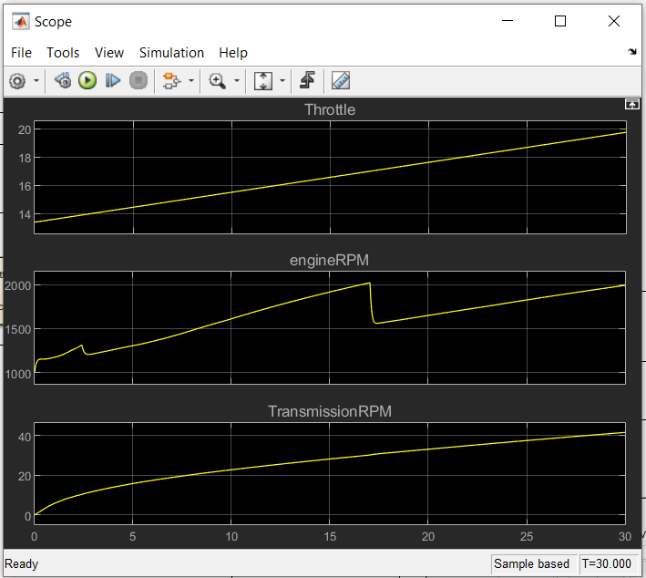

1. Hard Braking

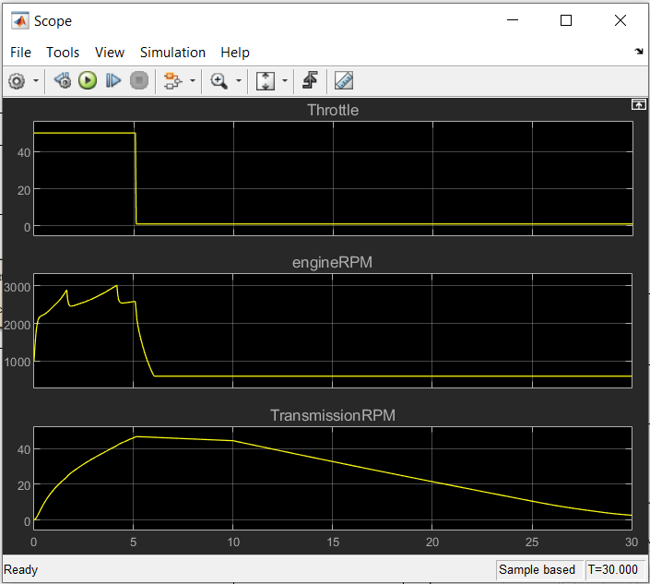

1. Coasting

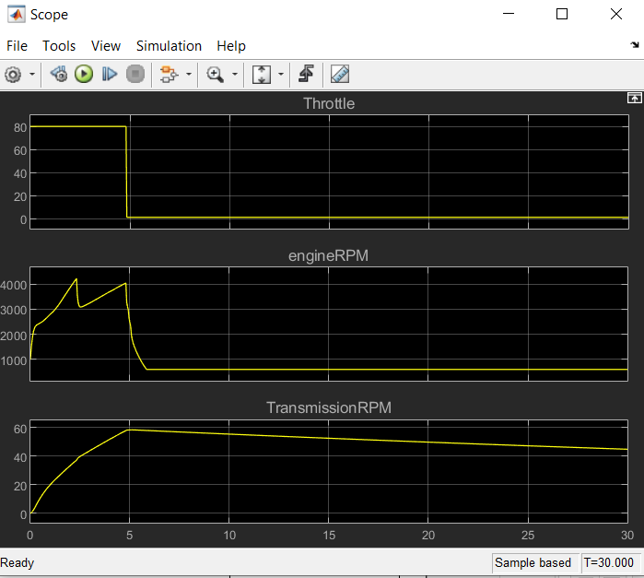

Conclusion:

The transmission system in the model is controlled in such a way that it automatically changes the behaviour of its transmission on the basis of the vehicle conditions that are experienced by the driver of the vehicle such as passing manoeuvre, gradual acceleration, coasting or hard braking.